**July/August Good News 2021**

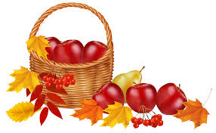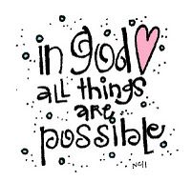Our ministry vision for the Virginia Annual Conference is ***“to be disciples of Jesus Christ who are lifelong learners, who influence others to serve.”***

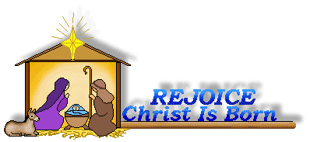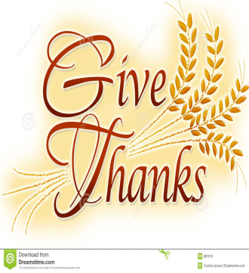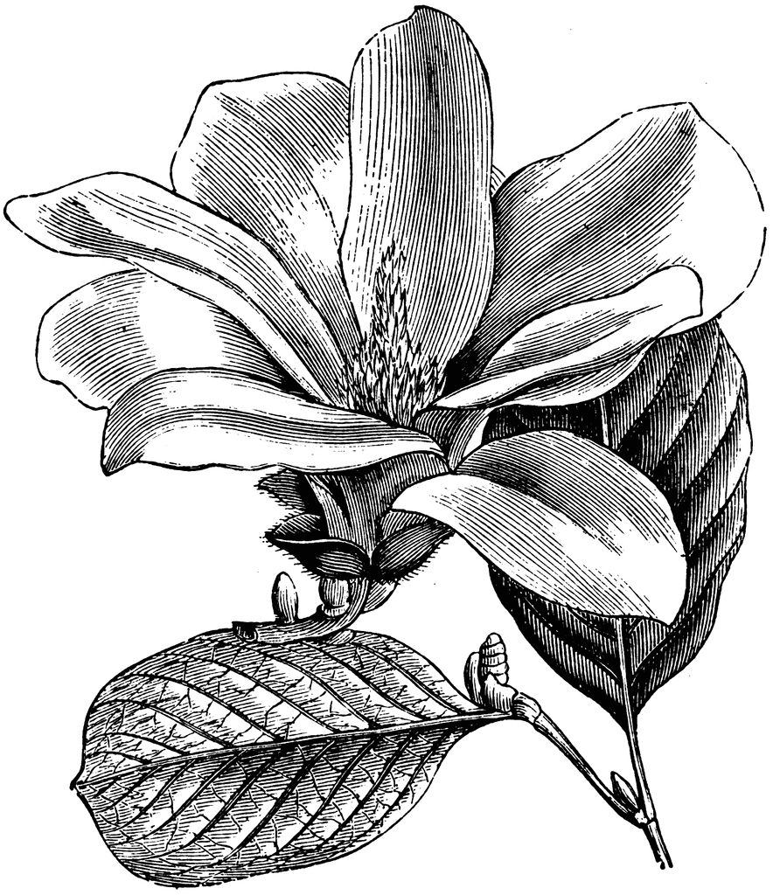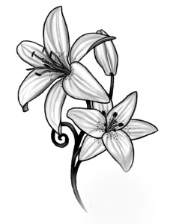

Welcome to Chestnut Hill UMC

***Rev. Adam White*** has completed 24 years in full-time ministry. He was licensed to preach in 1997 and was ordained a full member of the Virginia Annual Conference in 2001. He has served churches in Nelson County, the town of Amherst, and the Charlottesville area including both rural and suburban congregations. For the past 15 years he has been working in educational ministry as the chaplain at Sweet Briar College and Virginia Episcopal School. The fall of 2021 will mark his tenth year at VES, where he is chair of the Religion department teaching courses in New Testament and World Religions. All the while, Pastor Adam has been serving in part-time local church ministry while also fulfilling his roles as a chaplain and teacher. Most recently, he was pastor of the Mt. Pleasant Charge in Amherst. He finds that the balance of youth work and church work keeps him sharp and engaged with people across the full range of the life cycle. Educational ministry and local church ministry are both rich mission opportunities that work well together and mutually benefit and inform each other. He treasures his connection to the local church.

Rev. White will be fulfilling the role of Senior Pastor at Chestnut Hill beginning July 1 while also maintaining his appointment to VES. He is grateful for the assistance of Pastor Steve Stadtherr, who will be serving as Associate Pastor. Pastor Adam is deeply committed to the Lynchburg community, and is delighted to be serving in a city congregation.

Rev. White received a Bachelor of Science from Eastern Mennonite University and masters degrees from Drew University Theological School (M.Div.), Eastern Mennonite Seminary (M.A. in Religion), and the Lutheran Theological Seminary at Gettysburg (Master of Sacred Theology). He never tires of the joy of learning.

Rev. White has a daughter, Hannah White, who just completed her junior year at JMU and is now home in Lynchburg for the summer.

Pastor Adam enjoys reading, hiking, jogging, playing guitar, nature, classic movies, and of course, preaching the Word and administering the Sacraments. He will preach most Sundays per month and Pastor Steve will preach one Sunday per month. He looks forward to witnessing the gifts, graces, goodwill of the CHUMC community and sharing together in changing our little corner of the world for the better. Adam’s contact information: email:

awhite@ves.org.

***Steve Stadtherr***, a native of Forest, VA, will serve as Chestnut Hill’s new Associate Pastor serving along side Rev. Adam White. Steve currently resides in Rustburg, VA and is a member of New Hope UMC where he is adult Sunday School teacher, Board member, and member of the Laity. Steve has served the Lynchburg District UMC as a Lay Speaker for several years substituting for pastors on vacation, during illness, and for other necessary vacancies on Sunday mornings. He has completed several classes towards certification. By profession, however, Steve is an IT manager. His undergraduate degree is in Math and Computer Science from Emory and Henry College and his master’s degree is in Business Administration from Lynchburg College (now University of Lynchburg). Steve has been married to Annette Blankinship Stadtherr for 34 years and they are the parents of Michael Ryan (30) and Tyler (27) of Charleston, SC. Steve is an avid Duke basketball and Virginia Tech and LSU (the two schools his sons attended) football fan! However, he enjoys all sports and golfs and cycles whenever he gets the chance. He is often seen riding the Blackwater Creek trail with his 84-year old dad, Pat, who lives in Forest and works part-time at Tharpe Funeral Home, but he also does long- distance cycling as well. Steve is a member of the Rustburg Volunteer Fire Department and has been a member for 32 years. He has served as President, Vice-President, Treasurer and Secretary.

Steve’s contact information is: email: sps83.ss@gmail.com ; cell tele: 434.841.2458 and home tele: 434.332.6431. He looks forward to becoming a part of the CHUMC family.

**From Pastor Liz**

Dear Friends,

I wanted to take the time to express some thoughts as I prepare to depart Chestnut Hill UMC as your pastor. It has been a great appointment and I wish it could have lasted longer, but God and the Bishop had other plans. I have reached mandatory retirement age and can no longer serve a full time appointment. That is the Methodist system, and I fully support it. I am blest to be taking a part time appointment at Forest Road UMC. It was felt that I was in need at Forest Road UMC and so I will begin serving there at the end of June. You will be blest in the future by the leadership of Adam White and Steve Stadtherr, who in my opinion are men filled with God’s grace and the Holy Spirit and who are excited and able to lead you all into the future.

In my time here we have laughed together and cried together, shared in baptism, and too many deaths. We have shared the pains and joys of aging parents, raising grandchildren, losing jobs, failing health, depression, illness, surgery, birthdays and weddings. We have lived through the Covid 19 pandemic. I have loved serving here and loved each one of you. The Prayer Group has been a huge blessing to me. I’d like to feel that I have made some lasting friendships. I hope that I have touched your lives in some way, you have all touched mine.

Please give Adam and Steve the same kind of love and support that you have gifted me with. I will keep you in my heart and my prayers. Thank you for the honor and privilege of being your minister. God bless you all.

Blessing, Grace and Peace, Pastor **Liz**

**Reception for Pastor Liz**

There will be a reception in the Social Hall after church on Sunday, June 27 at 11:30 to give everyone a chance to say good-bye to Pastor Liz Ecklund, who is retiring.  That will be her last Sunday with us. We will be serving finger foods and punch. Anyone who can contribute to the food (homemade or purchased) please let Judy Robertson know by email, text or call (drobfor@msn.com, 434-851-2901). Also, we need people to help serve the

food and punch.

**Reception for New Pastors**

There will be a reception after church on Sunday, July 25, for our new pastors. I will

ask for specific help and food closer to that time.

~ *Judy Robertson*



Top of the Hill Program

Will resume in September.



*Mission Memo*

In March, April, and May we donated a total of 130.25lbs. of hygiene products that  Park View Mission valued at $238.63. Also 176.55lbs of food products that was valued at $308.89. They were very thankful for our help. Thank you to all who faithfully support this mission project. Covid-19 did not stop us!

For June, July, & August Park View Mission has requested we collect these items.

***Snack Foods***

Granola Bars, Breakfast Bars, packs of crackers, snack

size bags of chips, fruit cups, and Applesauce cups.

***Other Needs***

Laundry detergent, dish liquid, multi-surface cleaner,

paper towels, toilet paper, baby wipes, diapers sizes 5 & 6, body wash, shampoo & conditioner, and razors.   
                                  Thank you the Mission Committee

~Thank you, *Linda Jessen & The Mission Committee*

**Food Cart...**

 We will be collecting items for the Food Cart for ***Park View Community Mission.***

For the Month of **July/August**

**Snack foods:**

Granola Bars, Breakfast Bars, packs of crackers, snack size bags of chips, fruit cups, and

Applesauce cups.

**Other Needs:**

Laundry detergent, dish liquid, multi-surface cleaner, paper towels, toilet paper, baby wipes, diapers sizes 5 & 6, body wash, shampoo & conditioner, and razors.

This will assist people through *Park View Community Mission.* **NOTE: Please put all liquids in the box provided. Tape down all flip top bottles.**Please place in the food cart, located in the Commons. **Help those in need.**

Gifts & Memorials

*In Memory of:*

*Emily Morris*

Given by: Frances Unruh

*Sonny Smith*

Given by: Beryl Martin

All Are Welcome!

Chancel Choir begins, Thursday, September 2nd

6:30 p.m.

~*Heather Wilson*, Director of Music

The **Merry Marthas Circle** will not meet in July or August, but will resume meeting on the 2nd Wednesday of each month in September. We will plan to meet at church. Program to be announced later.

*~Judy Robertson*

**Prayer Group**

T***he Prayer Group*** will be resuming in September. For anyone who would like to join our group we meet on Tuesdays at 9:00 a.m. You are graciously accepted to join us in spending time in prayer and spending time with each other.

Chestnut Hill United Methodist Church extends Christian love

and sympathy to the family of *Radford “Sonny” Smith, III* and especially to his sister, Barbara LeFew. Mr. Smith passed away on June 2, 2021.

**Congratulations Graduate**

*Maris Tiller*. Graduating from Early College at CVCC (Summa Cum Laude) and Heritage High School with honors (top 15). Will be attending Mary Washington in the Fall.

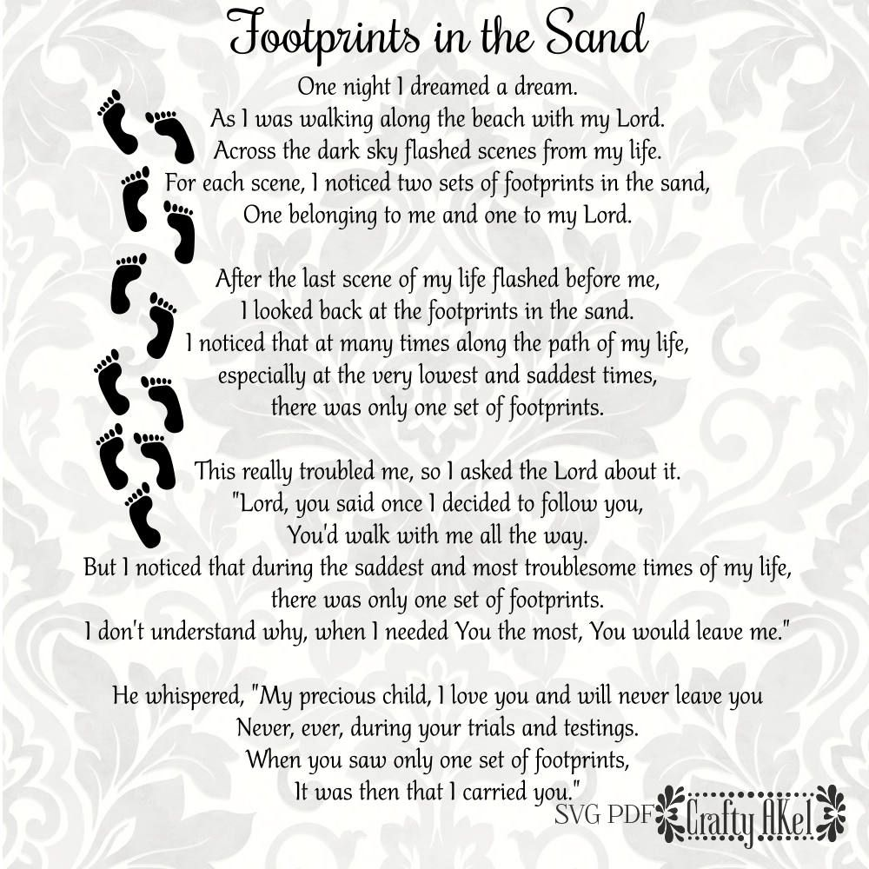

1  Kim

VandeBogart

2 Joella Edgreen

3 Ken Wood

4  Shaun

VandeBogart

6 Tommy Mason

7 Brian Jefferies

George Morcom

8 George Jessen

10 Rebecca Amos

Peggy Layne

11 Bradley Gilbert

Dewitt LeFew, Jr.

Patricia Pugh

12 Deborah Lacy

McKenna Mason

13 Phillip Reid

14 Robert Hamilton

15 Barry Redwood

16  Rev. Elizabeth

Ecklund

Inez Tolley

18  Jordan

VandeBogart

20  Kennedy

Ecklund

21 Barbara Blunt

22 Carolyn Anders

Stephanie Jones

23 Robbie Perrow

24 Jennifer Abbott

Judy Lease

25  Martha

Lipscomb

27 Susan Blunt

28 Robert Hicks

Brenda Hunt

Kelly Mason

29 Tucker Cole

30 Emily Lipscomb

Phyllis Rickwood

Delma Scott

Zachariah Weaver

31  Dean Burgess

Ashlyn Goolsby

1  Kim

VandeBogart

2 Joella Edgreen

3 Ken Wood

4  Shaun

VandeBogart

6 Tommy Mason

7 Brian Jefferies

George Morcom

8 George Jessen

10 Rebecca Amos

Peggy Layne

11 Bradley Gilbert

Dewitt LeFew, Jr.

Patricia Pugh

12 Deborah Lacy

McKenna Mason

13 Phillip Reid

14 Robert Hamilton

15 Barry Redwood

16  Rev. Elizabeth

Ecklund

Inez Tolley

18  Jordan

VandeBogart

20  Kennedy

Ecklund

21 Barbara Blunt

22 Carolyn Anders

Stephanie Jones

23 Robbie Perrow

24 Jennifer Abbott

Judy Lease

25  Martha

Lipscomb

27 Susan Blunt

28 Robert Hicks

Brenda Hunt

Kelly Mason

29 Tucker Cole

30 Emily Lipscomb

Phyllis Rickwood

Delma Scott

Zachariah Weaver

31  Dean Burgess

Ashlyn Goolsby

1  Kim

VandeBogart

2 Joella Edgreen

3 Ken Wood

4  Shaun

VandeBogart

6 Tommy Mason

7 Brian Jefferies

George Morcom

8 George Jessen

10 Rebecca Amos

Peggy Layne

11 Bradley Gilbert

Dewitt LeFew, Jr.

Patricia Pugh

12 Deborah Lacy

McKenna Mason

13 Phillip Reid

14 Robert Hamilton

15 Barry Redwood

16  Rev. Elizabeth

Ecklund

Inez Tolley

18  Jordan

VandeBogart

20  Kennedy

Ecklund

21 Barbara Blunt

22 Carolyn Anders

Stephanie Jones

23 Robbie Perrow

24 Jennifer Abbott

Judy Lease

25  Martha

Lipscomb

27 Susan Blunt

28 Robert Hicks

Brenda Hunt

Kelly Mason

29 Tucker Cole

30 Emily Lipscomb

Phyllis Rickwood

Delma Scott

Zachariah Weaver

31  Dean Burgess

Ashlyn Goolsby

|  |  |
| --- | --- |
| **Those Who Serve**  **Information will return**  **in the Fall.**  **************************  **GOOD NEWS** is published monthly for members and friends of Chestnut Hill United Methodist Church. Send articles to the church office by the 15th of the month. **(Subject to change.)**  **************************  **Our Attendance**  **Sunday School Worship**  6/6 30  6/13 30  6/20 34    **Each New Day a New Beginning**  *“New every morning is the love*  *Our wakening and uprising prove,*  *Through sleep and darkness safely brought*  *Restored to life, and power, and thought.”*  -John Keble | **Our Church Financial Picture**  Through the end of May 2021  General Operating Funds:  Needed to meet our 2021 Budget $ 222,943.00  Needed to meet our budget to date $ 92,893.00  Actual receipts to date $ 53,954.00  Shortage to meet budget to date $ 38,939.00  Actual expenditures to date $ 75,036.00  Shortage to meet expenses to date $ -21,082.00  Joy In Missions Funds:  Our Giving Goal for 2021 $ 11,600.00  Needed to meet our goal to date $ 4,833.00  Actual receipts to date $ 4,275.00  Special Offerings* (not budgeted):  Received to date $ 2,375.00  Dispersed to date $ 2,375.00  *Christmas, Easter, Annual Conference,  World Communion, etc.  **2021 Joy In Mission Donations**  To date, the following amounts have  been paid to the missions indicated.  1. Missionary Covenant Relationship $1,000 $250  2. Interfaith Outreach $1,000 $250  3. Park View Mission, Food for  Families $3,000 $880  4. Society of St. Andrew $1,000 $250  1. Adult Care Center $ 500 $125  2. Blue Ridge Area Food Bank $ 1,000 $250  3. Camp Timothy $ 500 $500  4. Churches for Urban Ministry $ 500 $125  5. Daily Bread $ 500 $125  6. Free Clinic $ 500 $125  7. Good Neighbor $ 500 0  8. Habitat for Humanity $ 500 $125  9. UMCOR-Non-Administrative $ 500 0  10. Undesignated $ 600 0  SPECIAL COLLECTIONS  UMCOR (One Great Hour of Sharing) $ 0  UMCOR (Tornado/Hurricane Relief) $ 0 |



*Chestnut Hill United*

*Methodist Church*

4660 Fort Avenue, Lynchburg, VA 24502

Phone Number: 434-239-8423: FAX: 434-239-7209

E-mail: [chestnuthillumc@comcast.net](mailto:chestnuthillumc@comcast.net)

On the web: www.chestnuthillumc.net

Church Office Hours

**Monday-Thursday~**9:00 am—3:30 pm

**Friday~**9:00 am-1:00 pm

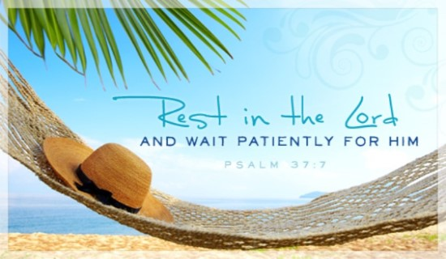

***DIRECTORY OF***

***CHESTNUT HILL UNITED METHODIST CHURCH***

|  |  |  |
| --- | --- | --- |
|  | Sharma Lewis | Richmond Area Resident Bishop |
|  | Denise Bates | Lynchburg District Superintendent |
|  | Adam White | Minister |
|  | Steve Stadtherr | Associate Minister |
|  | Monica C. Campbell | Administrative Assistant |
|  | Heather Wilson | Director of Music Ministry |
|  | Judy Martin | Bookkeeper |
|  | Judy Robertson | Lay Leader |